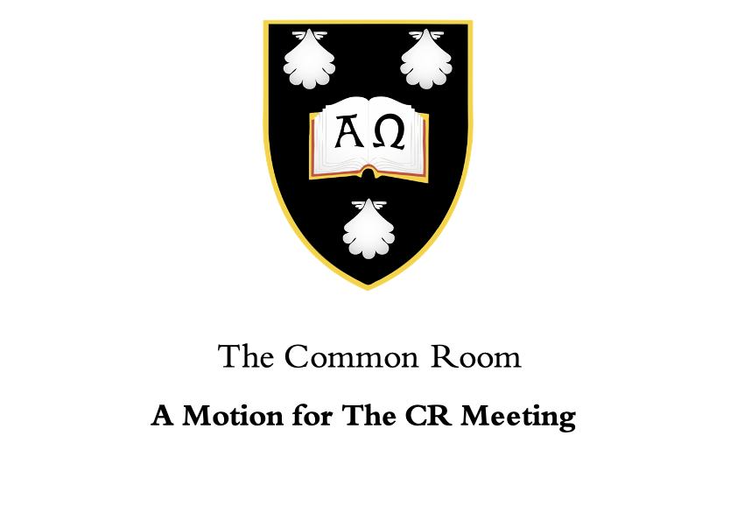

Date:

Motion Title:

This Common Room Notes: (what is the purpose for the motion)

- …

This Common Room Believes: (why is the purpose important)

- …

This Common Room Resolves: (what is the resolution the motion aims to achieve)

- …

Proposed by:

Seconded by:

